**FINAL PROJECT**

**BIA 660 – SPRING 2023**

**INTORDUCTION**

The past decade has seen remarkable growth in the adoption, use, and popularity of emerging technologies within most industries, including, but not limited to, the financial, public, educational, health, and research sectors (Ajana, 2015). The accounting field is not an exception (Fedyk et al., 2022; Cooper et al., 2019; Sun, 2019). The rapid advancement of technology has significantly transformed the way businesses operate and created new opportunities and challenges for professionals in various industries. In the accounting field, the adoption of emerging technologies has led to a shift in the required skillset for individuals to remain competitive and relevant in the job market. This has prompted a need to examine the changing skill requirements of accounting jobs, particularly those in highly regulated environments, where compliance with regulations is critical. Web mining techniques provide a valuable approach to studying the skills and qualifications required for accounting jobs in the current market. Through the analysis of job postings, web mining can reveal patterns and trends in the skills and qualifications sought by employers, as well as the impact of emerging technologies on the accounting profession. This information can be used by job seekers to develop their skillset to meet the changing demands of the job market and stay ahead of the competition.

Moreover, understanding the evolving skillset needs of accounting professionals can inform educational programs and training initiatives, helping to prepare future generations of accounting professionals with the skills needed to succeed in the field. Additionally, it can aid policymakers in creating effective policies to promote innovation and enhance the competitiveness of the accounting industry in the global market. In summary, the analysis of job postings using web mining techniques offers a promising avenue for examining the changing skillset needs of accounting jobs in highly regulated environments. This research can benefit job seekers, educational programs, training initiatives, and policymakers, contributing to the development of a skilled and competitive workforce in the accounting industry.

**PRELIMINARY LITERATURE REVIEW**

Many studies have examined the antecedents of applying these technologies in a well-regulated profession (i.e., accounting). With the rise of artificial intelligence and robotic process automation adoption in accounting and auditing, accountants and auditors are expected to possess willingness and openness to emerging technologies (Eulerich et al., 2021). This is important as they take the initiative to identify processes that might be automated (Kokina and Blanchette, 2019). This sheds light on the fact that minimum awareness of these technologies is a prerequisite for accountants and auditors to identify the use case of automation (Cooper et al., 2019).

Manita et al., 2020 also suggests that business schools and universities should adjust their training programs to reflect the audit firm’s expectations, as students should acquire the skill sets to process and analyze big data. This way, students will not only get to explore the technologies utilized but to enhance the student’s technology perception to ultimately adopt and rely on these technologies by illustrating perceived ease of use and perceived usefulness (Damerji and Salimi, 2021). In parallel, accounting department heads have demonstrated a significant commitment to investing in training programs to enhance the skill sets required to cope with the evolving demands and needs of the industry and practice. (Kend and Nguyen., 2020). These facts, where aggressive training programs are put to place, probably serves as an indicator that skills needed from an accountant today are different from what was needed perhaps a decade ago.

**OBJECTIVES & EXPECTED CONTRIBUTION**

We try to solve issues faced by job seekers (here accountants) to be more adaptive and job ready with the changing needs to keep up with constantly changing technology along with their field of expertise. We will be also taking the help of old job descriptions and requirements from OnetOnLine a government affiliated website to understand the job requirements and formulate a model that will solve or show the changing needs of on-the-job skills.

* **Research Question I -** What is the skill set needed as an Accountant these days?

It has been observed, changing trends and fast paced developments in technology has tend to penetrate in all the sectors or field of work Accounting is not spared either, hence there are emerging developments to build automation models using artificial intelligence and machine learning that demand the need to develop skills in areas like data analytics and coding. Apart from this Accountants also need to be upfront with their strategic abilities and knowledge to be upfront in the job.

* **Research Question II -** How are they different from the skill set needed a couple of years ago? When we look at the past decade there has been a huge change in the skill requirements for a job of accountant. Even today, due to emerging technologies the skills required on the job are constantly developing and moving towards new trends and technologies followed. This signifies the old school paper work or excel reports are moving towards a more automated way of working. To meet these demands and changing skill requirements we came up with this idea to formulate a way to understand the current trends and we expect our findings in this area and the model will contribute to solve following issues-
  + It will give a brief overview of the changing needs of their skill sets for the prospective job applications to Guide and follow the trend.
  + The students, prospective accountants, will be readily knowing the market demands and adapt and follow to improve their knowledge of various emerging technical aspects like automation. This will contribute to preparing them before

**METHODOLOGY**

1. **Information Extraction - Data Set Collected by Web Scrapping: data collection and pre-processing process**
2. **Python scripts for scraping and preprocessing**
3. **Exploratory data analysis (EDA) and/or initial text analysis**
4. **Text Analysis and Resultsusing NLP**

**PROCESS**

1. **Information Extraction - Data Set Collected by Web Scrapping: data collection and pre-processing process**

We have Scrapped data from job portal website indeed.com for the job title of Accountant. There were various fields that could be extracted as part of this task, but we focused on the ones that are necessary as part of our problem statement – to find evolution of skillset that are essential to step into the job market. This will help the job seekers to identify their skillset expertise and competencies expected to be in the job market.

After conducting a web scraping of job listings within the accounting profession on Indeed, we took the essential step of standardizing the job titles to ensure our findings were more comparable. Our analysis revealed that organizations often rely on internal processes to define job titles, resulting in job advertisements for similar roles being labeled differently across different companies. This inconsistency can lead to confusion and hinder efforts to compare job descriptions and duties accurately. For instance, a position advertised as "Junior Accountant’ in one company might be labeled as "Senior Accountant" in another. To overcome this challenge, we followed a rigorous and standardized procedure to categorize job titles based on the required years of experience.

Specifically, we classified all jobs advertised with up to two years of experience as "Junior Accountant," those advertised with three to six years of experience as "Senior Accountant," and those advertised with seven to ten years of experience as "Manager." It's worth noting that we didn't have to label the "Directors' since the number of job postings for these roles was low, and companies seem to have a consistent definition of the responsibilities of a director. These classifications were followed by the majority of the job postings. Our approach ensured that we categorized job titles consistently across all job postings, which enhanced the comparability of our findings.

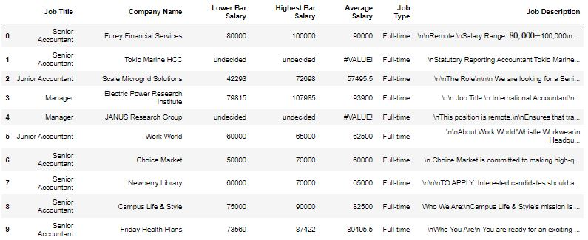

The table above depicts a sample of our dataset. We initially had 1974 observation where each observation is related to one job posting. We excluded all postings with missing job descriptions and missing titles. However, we did not delete any of the observations with missing salary expectations, as it is very common for job postings not to include such information. We also dropped all job postings related to auditors. Although the roles of both accountants and auditors complement each other, we are only interested in the roles of an accountant. This procedure reduced our number of observations to 1,868 observations. In addition, we filled the missing job types with “Full-time” as these job postings were offering contracts renewed every year upon agreement of two parties. We end up with 904 “Senior Accountant” positions, 636 “Junior Accountant” positions, 326 “Manager” positions, and finally with only 2 “Director” positions. It is important to note that the turnover rate for Directors in the accounting profession is low given that these positions are mostly filled with the brightest by head hunters. Figure 1 refers to the distribution of the job postings by job title.

1. **Python scripts for scraping and preprocessing**

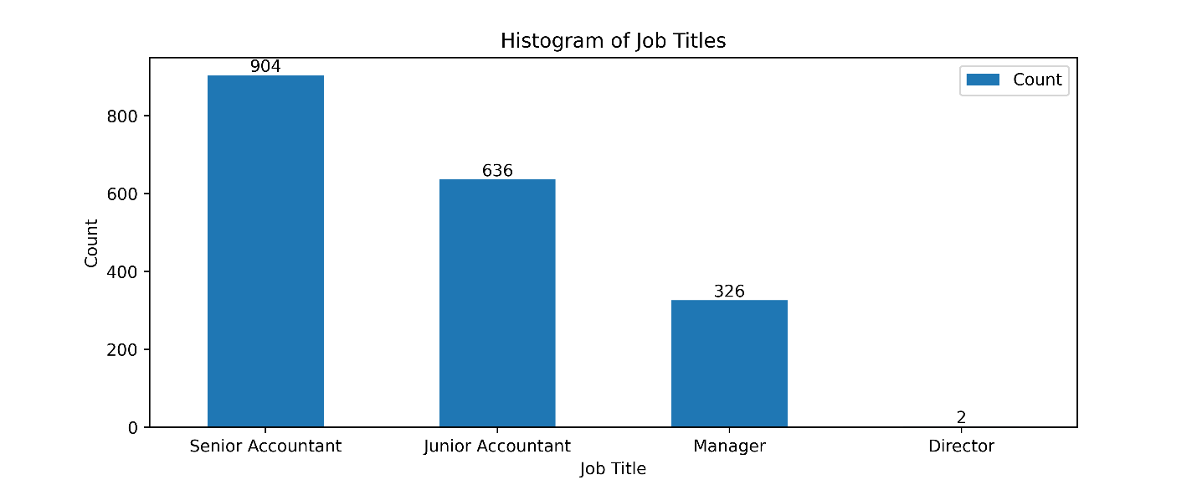

Figure 2 below shows the distribution of job types in the accounting field, with full-time positions making up the majority at 93.8%. Part-time positions account for only 6.1% of accounting jobs, while contract and internship positions are relatively rare. One potential reason for the prevalence of full-time positions in accounting could be due to the nature of the work. Accounting often requires a high degree of reliability, attention to detail, and consistency in order to maintain accurate financial records. Full-time employees may be seen as better suited for this type of work, as they are able to dedicate more time and effort to their roles. Offering a stable and reliable employment opportunity, companies may be able to entice skilled workers who are seeking long-term career opportunities.

Initially, the salary was reported as “110,000$ -120,000$ a year” for example. Therefore, we split the information to measure the average lower bar and average higher bar salaries with respect to each role. We also measured the meaning of both the lower and higher bar of salary for comparative purposes. The Junior Accountant position has an average lower bar salary of $62,521.69, while the Senior Accountant position has $87,926.07. The Manager position has an average lower bar salary of $82,670.58, which is slightly lower than the Senior Accountant position. The Director position has the highest average lower bar salary of all the job titles, with a value of $203,175.00. These figures provide insight into the salary distribution across job titles in the accounting field. The unexpected variation in salary between senior accountants and managers may be attributed to the possibility that these positions share similar job functions and may even be interchangeable. Depending on the company's organizational structure and culture, the terms "senior accountant" and "manager" could be used interchangeably, with individuals in these roles performing identical duties but simply holding different titles. Figure 3 shows the Average Lower Bar Salary per job title.

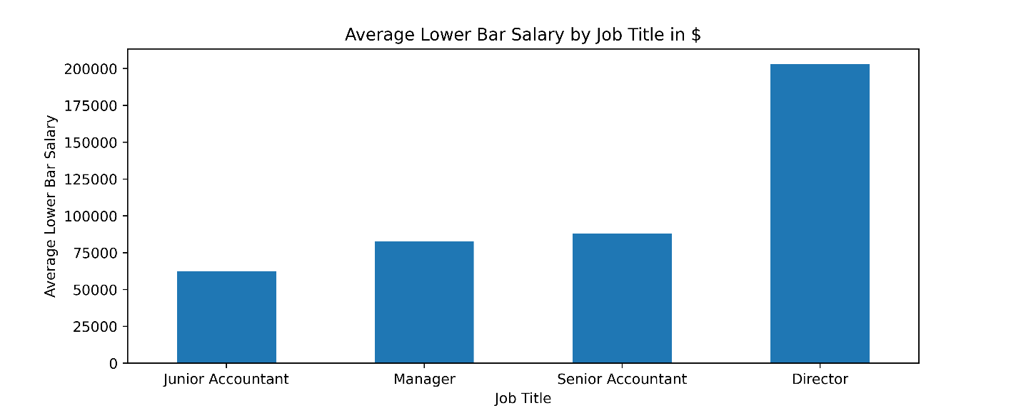

Figure 4 displays the descriptive statistics of the average higher bar salary for each job title industry. The Junior Accountant position has a mean highest bar salary of $80,716, while the Senior Accountant position has a slightly higher mean of $84,642. The Manager position has the highest mean highest bar salary of $87,339, followed by the Director position, which has a mean highest bar salary of $218,175.

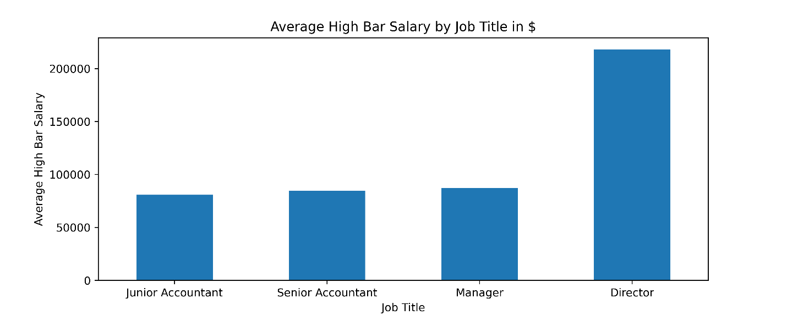

Figure 5 shows the descriptive statistics of the average salaries for different job titles in the accounting industry. The average salary for Junior Accountants is $69,862, which is the lowest among the job titles. The average salary for Senior Accountants is $86,800, slightly higher than the average salary for Managers at $85,043. The highest average salary is for Directors at $169,425, which is more than double the salary of Junior Accountants. These statistics suggest that experience and seniority play a significant role in determining salaries in the accounting industry.

**ONETONLINE**

Onetonline is a website that provides comprehensive information on various careers and occupations in the United States. It is sponsored by the U.S. Department of Labor, Employment and Training Administration. The website includes a searchable database of over 1,000 occupations and provides information such as job duties, required skills and knowledge, educational and training requirements, median pay, and job outlook. It also offers tools for job seekers, such as a career exploration tool, resume builder, and job search function. The website is a valuable resource for individuals who are looking for information on potential careers or seeking to advance their careers.

To validate the reliability and accuracy of our findings on the essential soft and technical skills required for accounting jobs, we employed a website as a benchmark for comparison. The website was utilized to compare our findings to the reported soft and technical skills. The results of this comparison were intriguing and worth discussing in further detail. Accounting software has become an essential tool for accountants to efficiently perform their daily tasks. Fund accounting software, such as QuickBooks and Sage 50 Accounting, has enabled accountants to manage financial records, track transactions, and generate financial reports. The adoption of Summit Software Summit Biofuels Accounting has also facilitated the management of specialized accounting needs, such as managing financial transactions and inventory for biofuel companies. These software applications have streamlined accounting processes, reduced the chances of errors, and increased efficiency in managing financial data.

Enterprise resource planning (ERP) software, including SAP, Oracle, Sage Microsoft Dynamics, Platinum for Windows PFW, and has also become integral for accountants. These software applications provide a comprehensive suite of tools to manage business operations and financial data. ERP software has enabled accountants to integrate different systems and processes, automate financial workflows, and generate real-time financial data for decision-making purposes. The adoption of ERP software has increased the accuracy of financial reporting, improved productivity, and enhanced financial control.

Moreover, financial analysis software, such as Delphi Technology, Oracle E-Business Suite Financials, TopCAATs, and Tropics workers' compensation software, has enabled accountants to conduct comprehensive financial analysis, forecasting, and reporting. These software applications have provided tools to extract data from multiple sources, analyze financial data, and generate financial models. The adoption of financial analysis software has enabled accountants to provide accurate and timely financial reports, reduce the chances of errors, and make informed financial decisions. Proficiency in tax preparation software, including ATX Total Tax Office, Intuit TurboTax, NewPortWave Year End Solutions, and Thomson GoSystem Tax, is also critical for accountants to prepare and file tax returns. Lastly, proficiency in word processing software, such as Google Docs, Microsoft OneNote, and Microsoft Word, is essential for accountants to create professional reports and documents.

"It is crucial to compare this information with our own discoveries. Additionally, we have found that proficiency in QuickBooks, Sage, and Oracle is among the most important software skills needed. However, when it comes to the soft skills, being a “team member”, “collaborating” with other accounting members is somehow a dominant requirement within the accountant’s job description.

1. **Exploratory data analysis (EDA) and/or initial text analysis:**

Parsing / Annotation

Further we have identified the most frequently occurring words in the job description which are aligned with the skill requirements and extract words to lemmatize and perform Named Entity Recognition.  
Using Word cloud we were able to find the most frequent words that are aligned with the required skillset for an job description and extract them based on Word cloud model just to visualize their importance in the document overall.

1. Preprocess the job description text data by removing stop words, punctuation, and non-alphabetic characters, and convert all text to lowercase.
2. Extract only the technical skill words from the preprocessed text data. This can be done using a list of known technical skill words or by using a pre-trained word embedding model to identify technical skill words.
3. Use the extracted technical skill words to generate a word cloud.

We have used the nltk library for text pre-processing and the gensim library for word embedding. Then we focused on the technical skills and generate the worldcloud based on their frequency – We found –

Based on TFIDF Scores for specific skills

1. Technical skills

1. Personality skills specifically

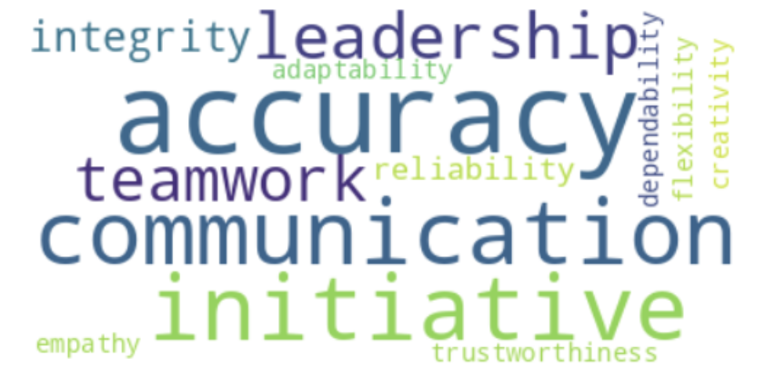

To be most frequent.  
e. Feature Extraction - Vector spaced models/Word vectors  
Further we will be finding a way to extract the exact skills from the job description to know more better with text mining procedures to extract the relevant skillsets. Then, we form the word vectors out of the dataset to perform a full understanding of the most important words or job skill requirements in current days. This will help us to compare the previous dataset with skill requirements with the current trends.

f. Text Mining - Supervised Learning Classification  
Once done with the data analysis we will be using this to extract the skills and classify them according to the technological and accountant related job requirements.

**Brief Project Schedule**

Our project can be divided into the following tasks:

**Task Performed**

(1) Data collection  
(2) Data preprocessing  
(3) Account classification Method 1  
(4) Job title Analysis  
(5) Hypothesis testing and interpretation   
(6) Research report writing

**REFERENCES**

Ajana, B. (2015). Augmented borders: Big Data and the ethics of immigration control, Journal of Information, Communication and Ethics in Society, 13 (1), pp. 58-78.

Fedyk, A., Hodson, J., Khimich, N., & Fedyk, T. (2022). Is artificial intelligence improving the audit process? Review of Accounting Studies, 27(3), 938-985.

Cooper, L. A., Holderness Jr, D. K., Sorensen, T. L., & Wood, D. A. (2019). Robotic process automation in

public accounting. Accounting Horizons, 33(4), 15-35.

Sun, T. (2019). Applying deep learning to audit procedures: An illustrative framework. Accounting Horizons, 33(3), 89-109

Manita, R., Elommal, N., Baudier, P., & Hikkerova, L. (2020). The digital transformation of external audit and its impact on corporate governance. Technological Forecasting and Social Change, 150, 119751.

Damerji, H., & Salimi, A. (2021). Mediating effect of use perceptions on technology readiness and adoption

of artificial intelligence in accounting. Accounting Education, 30(2), 107-130.

Kend, M., & Nguyen, L. A. (2020). Big data analytics and other emerging technologies: the impact on the Australian audit and assurance profession. Australian Accounting Review, 30(4), 269-282.